SEISMIC ANALYSIS OF R.C BUILDING ON SLOPING GROUND

Mohammed Faizuddin^{1,} A.Nagaraju ².
¹PG Student, CMR Technical Campus, Department of Civil Engineering, Hyderabad.
²Assistant Professor, CMR Technical Campus, Department of Civil Engineering, Hyderabad.
¹mohammedfaizuddin129@gmail.com

Abstract. Shear wall systems are one of the most commonly used lateral load resisting systems in high-rise buildings, Shear walls have very high in plane stiffness and strength, which can be used to simultaneously resist large horizontal loads and support gravity loads, making them quite advantageous in many structural engineering applications. There are lots of literatures available to design and analyze the shear wall. However, the decision about the location of shear wall in multistory building is not much discussed in any literatures.
In this Analysis, therefore, main focus is to determine the solution for shear wall location in multi storey building. The shear walls will be introduced in the framed structure at suitable locations and the analysis is made for both for static and dynamic loads caused due to earthquakes. A RCC building of 6 storey placed subjected to earthquake loading in zone-II is considered. An earthquake load is calculated by seismic coefficient method using IS 1893(PART-I):2002. These analyses were performed using STAAD Pro. A study has been carried out to determine the strength of RC shear wall of a multistoried building by charging shear wall location. The proposed six storey building is first analyzed without shear walls. The three different cases of shear wall position for a 6 storey building have been analyzed later. The results of the above four analysis will be compared and optimize the shear wall frame structure i.e. (shear walls and frames) will be suggested for the building considered for the analysis. This analysis will help in achieving safety against earthquakes as well as keeping the flexibility of the frame structure intact. It is concluded that incorporation of shear wall has become inevitable in multistory buildings to resist lateral forces. The type II shear wall proposed in this analysis proves to be more efficient and will achieve maximum safety towards earthquakes in zone-Il
Key words: Multi-storey, RC structure, seismic analysis, RC shear wall, STADD Pro.

Introduction
India is one of the countries which are highly prone to earthquakes of magnitude more than 6. More than 60% of the land area is prone to shaking of intensity 7 and above. In fact, the entire Himalayan belt is considered prone to greatest earthquakes of magnitude greater than 8.0. In a short span of 50 years four such great earthquakes have occurred viz., 1897 Assam (M 8.7), 1905 Kangra (M8.6), 1934 Bihar-Nepal (M8.4) and 1950 Assam-Tibet (M8.7).[22] India has relatively high frequency of greater earthquakes and relatively low frequency of moderate earthquakes.
In some parts of world, hilly region is more prone to seismic activity; e.g. northeast region of India. In hilly regions, locally available traditional material like, the adobe, brunt brick, stone masonry and dressed stone masonry, timber reinforced concrete, bamboo, etc., is used for the construction of houses. The scarcity of plain ground in hilly areas compels construction activity on sloping ground resulting in various important buildings such as reinforced concrete framed hospitals, colleges, hotels and offices resting on hilly slopes. Since, the behavior of buildings during earthquake depends upon the distribution of mass and stiffness in both horizontal and vertical planes of the buildings, both of which vary in case of hilly buildings with irregularity and asymmetry due to step back frame and setback-step back frame configuration. Such constructions in seismically prone areas make them exposed to greater shears and torsion as compared to conventional construction. Hill buildings constructed in masonry with mud mortar or cement mortar without conforming to seismic codal provisions have proved unsafe and resulted in loss of life and property when subjected to earthquake ground motions. The economic growth and rapid urbanization in hilly region has accelerated the real estate development. Due to this, population density in the hilly region has increased enormously. Therefore, there is popular and pressing demand for the construction of multi-storey buildings on hill slope in and around the cities. It is observed during the past earthquakes, buildings in hilly regions have experienced high degree of damage leading to collapse though they have been designed for safety of the occupants against natural hazards. Hence, while adopting practice of multi-storey buildings in these hilly and seismically active areas, utmost care should be taken for making these buildings earthquake resistant.

Methodology and Materials

Building Configuration
in the present study, three groups of building (i.e. configurations) are considered, out of which first one is on the plain ground and the two are resting on ground.
➢Setback buildings.
➢Step back buildings.
➢Setback -Step back buildings.

Material Properties

Grade of concrete: M30
Grade of steel: Fe 415
Modulus of elasticity of reinforced concrete as per IS 456:2000 is given by
Ec = 5000√fck

Where fck= Characteristic compressive strength of concrete at 28-days in MPa.

Loading

Live load on typical floor: 4 kN/m2
Live load on terrace floor: 1.5 kN/m2
Floor finish: 1kN/m2

Geometrical Properties
Dimension of beam: 450X450 mm
Table 2.1: Geometrical properties of column for different configuration of building
Building configuration | Dimension of columns
 | Group 1 | Group 2 | Group 3 | Group 4
G+3 Setback (00) | 230X230 | ------ | ------- | --------
G+3 Step back (150) | 230X230 | ------ | ------- | --------
G+3 Setback-step back (150) | 230X230 | ------ | ------- | --------
G+3 Step back (300) | 230X230 | ------ | ------- | --------
G+3 Setback-step back (300) | 230X230 | ------ | ------- | --------
G+5 Setback (00) | 230X230 | ------ | ------- | --------
G+5 Step back (150) | 230X230 | ------ | ------- | --------
G+5 Setback-step back (150) | 230X230 | ------ | ------- | --------
G+5 Step back (300) | 230X230 | ------ | ------- | --------
G+5 Setback-step back (300) | 230X230 | ------ | ------- | --------
G+8 Setback (00) | 230X230 | 300X300 | 350X350 | 450X450
G+8 Step back (150) | 400X400 | 450X450 | 350X350 | 230X230
G+8 Setback-step back (150) | 400X400 | 450X450 | 350X350 | 230X230
G+8 Step back (300) | 400X400 | 450X450 | 350X350 | 230X230
G+8 Setback-step back (300) | 400X400 | 450X450 | 350X350 | 230X230

Basic Data
Height of typical floor: 3.5 m
Ground of typical floor: 3.5 m
Slab Thickness: 120 mm
Walls: 230 mm thick brick wall
Type of soil: Type II, medium soil
Type of frame: Special RC moment resisting frame (SMRF)
Seismic zone: III
Response reduction factor: 5
Importance factor: 1
Damping of structure: 5%
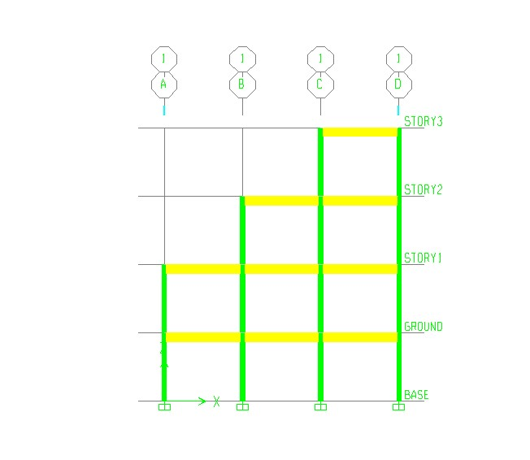
Figure 2.1 Elevation of setback building for three storey model (00 slopes)
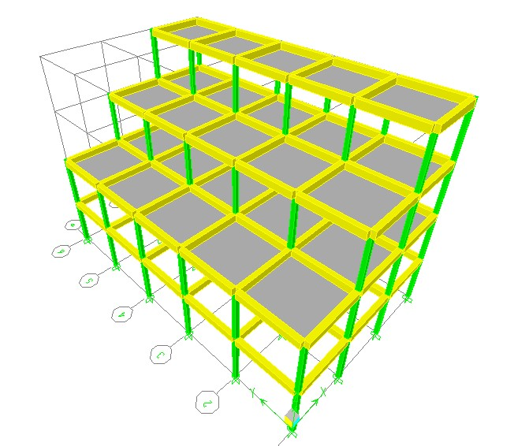
Figure 2.2 Three dimensional view of setback building for three storey model (00 slope)
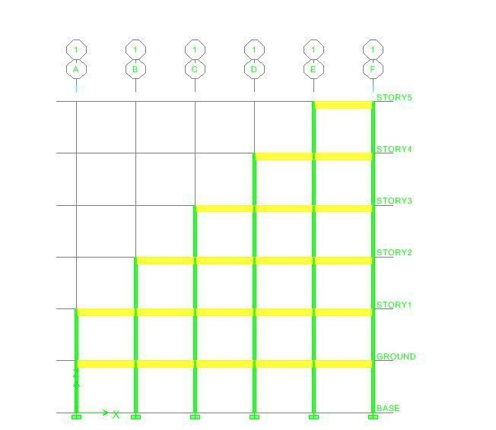
Figure 2.3 Elevation of setback building for five storey model (00 slope)

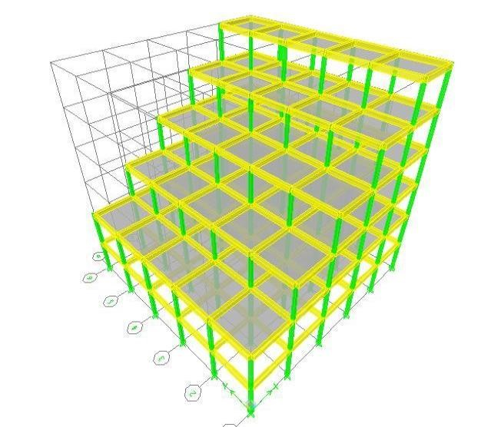
Figure 2.4 Three dimensional view of setback building for five storey model (00 slope)
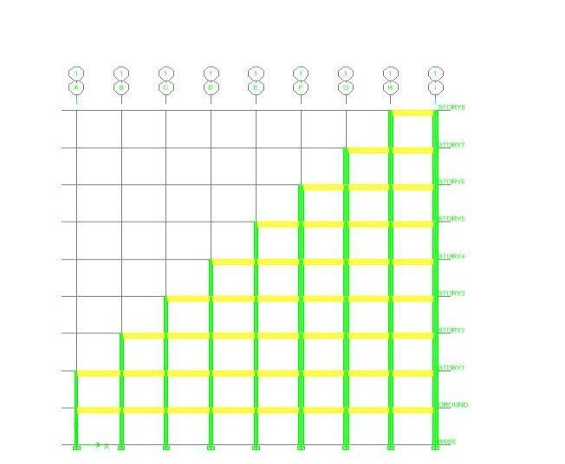
Figure 2.5 Elevation of setback building for eight storey model (00 slope)
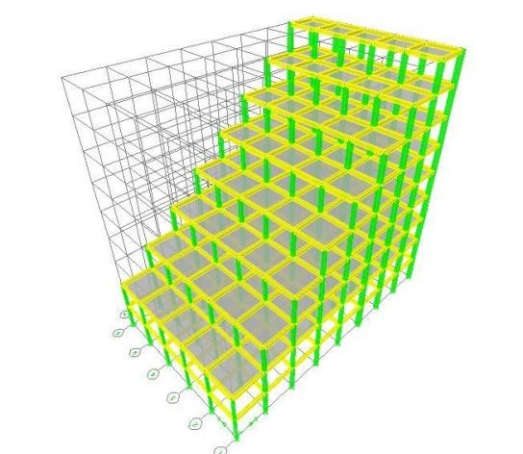
Figure 2.6 Three dimensional view of setback building for eight storey model (00 slope)

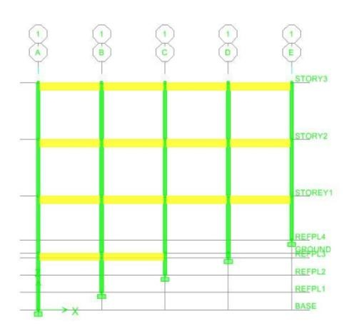
Figure 2.7 Elevation of step back building for three storey model (150 slope)

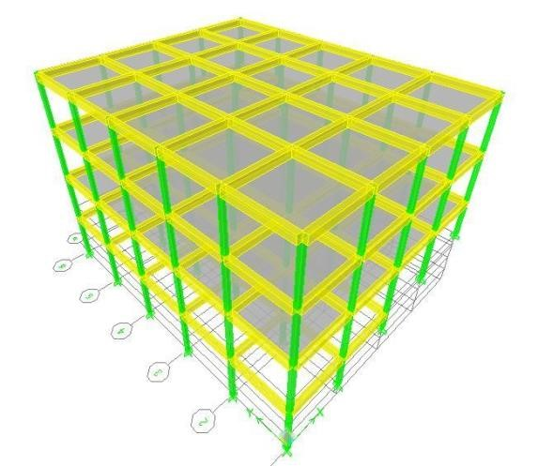
Figure 2.8 Three dimensional view of step back building for three storey model (150 slope)
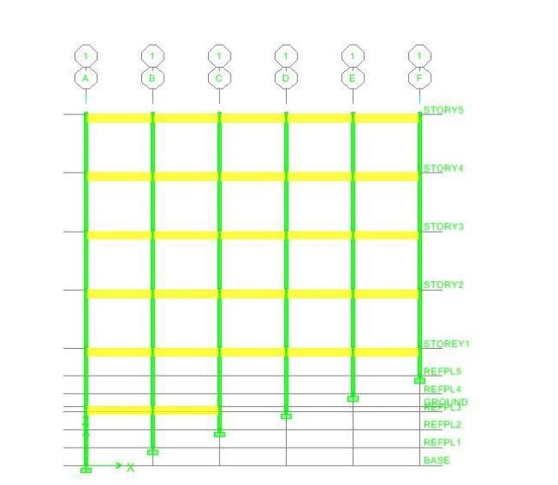
Figure 2.9 Elevation of step back building for five storey model (150 slope)
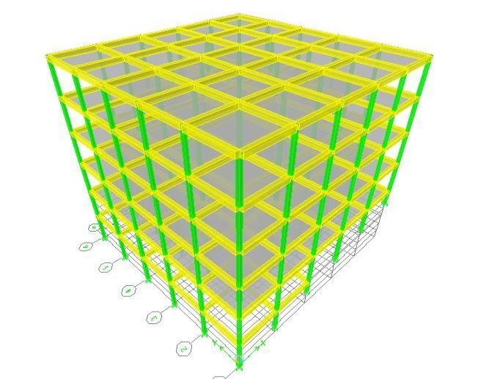
Figure 2.10 Three dimensional view of step back building for five storey model (150 slope)
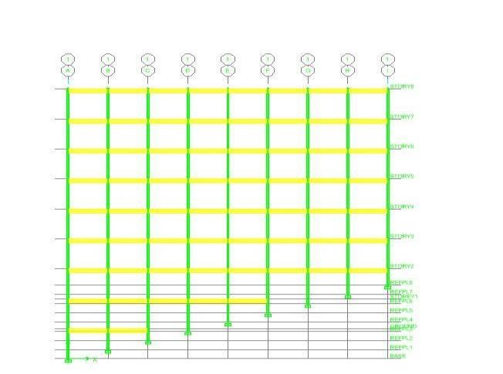
Figure 2.11 Elevation of step back building for eight storey model (150 slope)
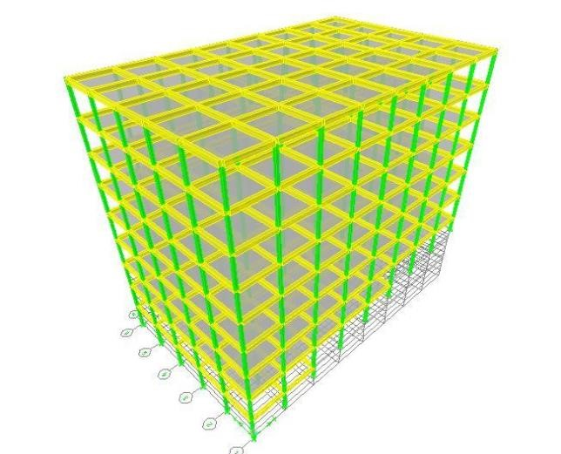
Figure 2.12 Three dimensional view of step back building for eight storey model (150 slope)

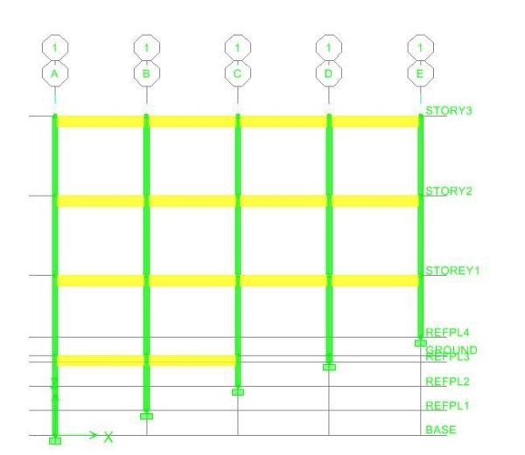
Figure 2.13 Elevation of step back building for three storey model (300 slope)
Figure 2.14 Three dimensional view of step back building for three storey model (300 slope)
Figure 2.15 Elevation of step back building for five storey model (300 slope)

Figure 2.16 Three dimensional view of step back building for five storey model (300 slope)
Figure 2.17 Elevation of step back building for eight storey model (300 slope)
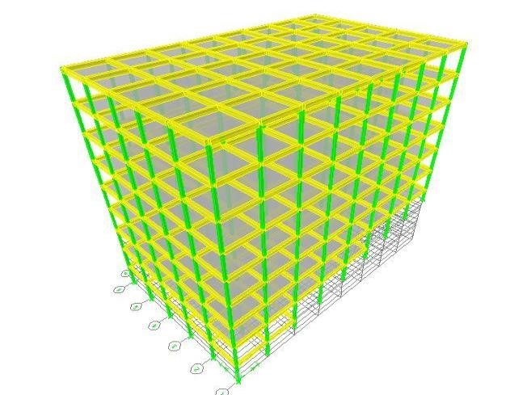
Figure 2.18 Three dimensional view of step back building for eight storey model (300 slope)

Results and Discussion
The three different configuration setback, step back and setback-step back are analyzed using static and dynamic method of analysis and results are obtain and the same are discussed in this chapter.

Table 3.1 Lateral load distribution for setback building model
 | Lateral Force (Q), kN
S.no | Storey level | By Linear static method | By Response spectrum method
1 | 8 | 60.153 | 43.85
2 | 7 | 82.702 | 68.870
3 | 6 | 90.248 | 127.898
4 | 5 | 86.090 | 160.773
5 | 4 | 73.524 | 219.082
6 | 3 | 51.583 | 236.238
7 | 2 | 33.962 | 293.963
8 | 1 | 17.927 | 274.151
9 | Ground | 2.457 | 300.801

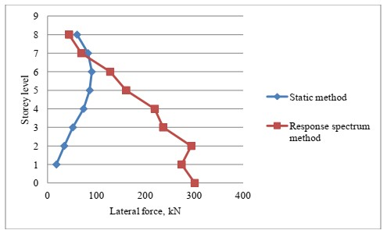
Figure 3.1 Lateral load distributions for setback building

Table 3.2 Maximum displacement value for eight storey model
S.no | Storey  number | Plane ground | Sloping ground
 |  |  | 150 |  | 3 | 00
 |  | Setback (m) | Step back (m) | Setback step back  (m) | Step back  (m) | Setback step back  (m)
1 | 8 | 0.0259 | 0.0195 | 0.0206 | 0.0211 | 0.0150
2 | 7 | 0.0257 | 0.0137 | 0.0189 | 0.0184 | 0.0100
3 | 6 | 0.0236 | 0.0121 | 0.0102 | 0.0099 | 0.0072
4 | 5 | 0.0206 | 0.0111 | 0.0089 | 0.0067 | 0.0055
5 | 4 | 0.0174 | 0.0083 | 0.0067 | 0.0022 | 0.0012
6 | 3 | 0.0138 | 0.0067 | 0.0043 | 0.0020 | 0.0007
7 | 2 | 0.0101 | 0.0029 | 0.0023 | 0.0014 | 0.0003
8 | 1 | 0.0063 | 0.0009 | 0.0006 | 0.0009 | 0.0002
9 | Ground | 0.0027 | 0.0001 | 0.0001 | 0.0006 | 0.0000

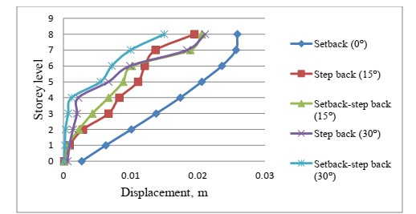
Figure 3.2 Maximum displacement values for eight storey model

Table 3.3 Maximum displacement value for five storey model

S.No. | Storey number | Plane ground |  | Sloping ground
 |  |  | 1 | 50 |  | 300
 |  | Step back (m) | Step back (m) | Setback step back  (m) | Step back  (m) | Setback step back  (m)
1 | 5 | 0.0144 | 0.0103 | 0.0101 | 0.0123 | 0.0095
2 | 4 | 0.0134 | 0.0087 | 0.0072 | 0.0096 | 0.0068
3 | 3 | 0.0096 | 0.0069 | 0.0055 | 0.0054 | 0.0029
4 | 2 | 0.0062 | 0.0042 | 0.0033 | 0.0013 | 0.0006
5 | 1 | 0.0039 | 0.0016 | 0.0012 | 0.0006 | 0.0003
6 | Ground | 0.0022 | 0.0003 | 0.0002 | 0.0003 | 0.0000

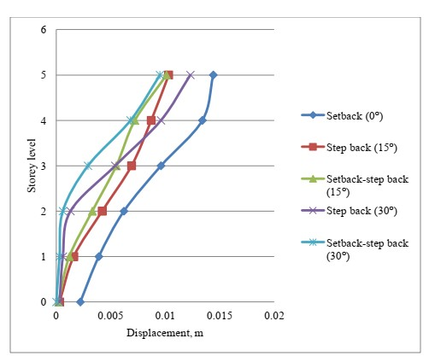
Figure 3.3 Maximum displacement values for five storey model

Table 3.4 Maximum displacement value for three storey model

S.no | Storey number | Plane ground | Sloping ground
 |  |  | 150 |  | 3 | 00
 |  | Step back (m) | Step back (m) | Setback step back  (m) | Step back  (m) | Setback step back  (m)
1 | 3 | 0.0251 | 0.0071 | 0.0066 | 0.0045 | 0.0079
2 | 2 | 0.0191 | 0.0052 | 0.0045 | 0.0012 | 0.0050
3 | 1 | 0.0129 | 0.0031 | 0.0021 | 0.0005 | 0.0022
4 | Ground | 0.0077 | 0.0004 | 0.0003 | 0.0001 | 0.0002

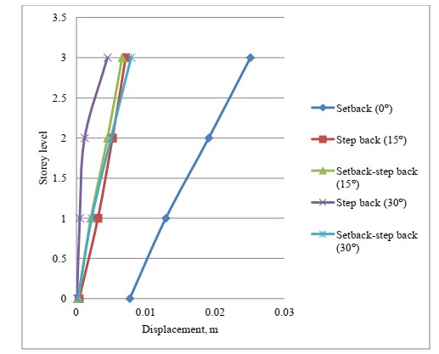
Figure 3.4 Maximum displacement values for three storey model

Conclusion

- The step back building gives higher value of displacement as compared with setback-step back building.
- The step back building gives higher time period compared to setback-step back building.
- In step back and setback-step back building it is observed that the columns at the higher side of slope which are short are more affected.
- During earthquake step back building performance is very poor compared to setback-step back building.
- The step back building produces more torsion compared to setback-step back building. If step back building are adopted then proper design should be done for additional bending moment due to earthquake.

5.References

- D.K.Paul and Satish Kumar, “Stability analysis of slope with building loads” Soil Dynamics and Earthquake Engineering, Volume 16, Issue 6, August 1997.
- Satish Kumar and D.K Paul, “Hill building configurations from seismic considerations” Journal of Structural Engineering, India, (SCRC) 1999.
- B.G. Birajdar, S.S. Nalawade, “Seismic analysis of buildings resting on sloping ground” 13th World Conference on Earthquake Engineering, Vancouver, B.C., Canada, August 2004.
- Dhiman Basu, Sudhir K.Jain, “Alternative method to locate centre of rigidity in asymmetric buildings” Earthquake Engineering and Structural Dynamic, volume 36, 2006.
- S.Kumar, “A Simplified Method for Elastic Seismic Analysis of Hill Buildings” Journal of Earthquake Engineering, volume 2, 1998.
- K.C. Biswal (2010), “Design of Earth-Quake Resistant Multi-Storied R.C.C Building on
Sloping Ground” Department of Civil Engineering, National Institute of Technology, Rourkela, 2010.
- Mohammed Umar Farooque Patel, A.V.Kulkarni, Nayeemulla Inamdar, “A Performance Study and Seismic Evaluation of RC Frame Buildings on Sloping Ground” IOSR Journal of Mechanical and Civil Engineering (IOSR-JMCE), 2014.
- Ajay Kumar Sreerama, Pradeep Kumar Ramancharla, “Earthquake Behavior of Reinforced Concrete Framed Buildings on Hill Slopes” International Symposium on New Technologies for Urban Safety of Mega Cities in Asia (USMCA), 2013
- Satish Kumar and D.K Paul, “Dynamic Analysis of Step back and Setback Building” Proceedings of the Tenth Symposium on Earthquake Engineering, November 1994.
- Ashok K.Jain and Satish Annigeri - "Torsional Provisions for Asymmetrical Multi-storey buildings" Proceedings of the Tenth Symposium on Earthquake Engineering, November1994.
- A.S.Warudkar, R.P.Sudarsan and G.Visalakshi, "Effect of torsional stiffness on the dynamic response of RC framed structures" Proceedings of the Tenth Symposium on Earthquake Engineering, November 1994.
- Pankaj Agarwal and Manish Shrikhande, "Earthquake Resistant Design of Structures” Prentice Hall of India, 2006.
- S.K.Duggal, "Earthquake Resistant Design of Structures" Oxford University Press, 2007. [14] Bungalc S.Taranath "Reinforced concrete design of tall buildings”.
- CRC Press, 2001 Bungalc S. Taranath, "Wind and Earthquake resistant buildings, Structural analysis and design" Marcel Dekkcr, 2005.
- Sudhir K Jain, “Explanatory Examples on Indian Seismic Code IS 1893 (Part-I)” IITKGSDMA
Project on Building Codes, 2007.
- H. J. Shah and Sudhir K Jain, “Design Example of a Six Storey Building” Document No- IITK-GSDMA-EQ26-V3.0, IITK-GSDMA Project on Building Codes,
- A.R. Vijaya Narayanan, Rupen Goswami and C.V.R. Murty, “Performance of RC Buildings along Hill Slopes of Himalayas during 2011 Sikkim Earthquake” Indian Institute of Technology Madras, Chennai, India, 2012.
- IS-456, (2000), "Indian standard Code of practice for Plain and Reinforced Concrete (Fourth revision)" Bureau of Indian Standards, New Delhi.

