S Munavvar Hussain
Electronics and Communication Engineering Department
B.V.Raju Institute of Technology, Telangana, India.
Assistant professor,
Hussain.munavvar@bvrit.ac.in

D.Yashwanth Krishna, B.Anusha, B.Vijaya Neelam, D.Roshan Kumar
Electronics and Communication Electronics and Communication Electronics and Communication Electronics and Communication
Engineering Department Engineering Department Engineering Department Engineering Department
B.V.Raju Institute of Technology, B.V.Raju Institute of Technology, B.V.Raju Institute of Technology, B.V.Raju Institute of Technology
Telangana, India. Telangana, India. Telangana, India. Telangana, India.
18211a0457@bvrit.ac.in 18211a0440@bvrit.ac.in 18211a0437@bvrit.ac.in 18211a0451@bvrit.ac.in

Development of a Convolution Neural Network Model for Pest Classification using TensorFlow with Keras
Abstract:
Agriculture is the main source of life in India. Almost 70% of rural life practices farming. One of the major problems for a farmer is the pests in his field. Identifying the pest is also a main reason where a farmer fails. Recognizing the pest in the initial stage and using appropriate pesticides are the primary key elements to save the crop from huge losses. So, this paper describes the use of Image Processing techniques by developing a Convolution Neural Network model using TensorFlow with Keras to identify the pest in the image uploaded using LabVIEW software and achieved an accuracy of 95%.

Only identifying the pest would not solve the problem, but the pesticides that to be used for the eradication of pets is the final objective. Farmer is to be informed with the respective pesticide that can be used to eradicate the pest. An image with a pest in it will be considered as an input in LabVIEW with NI Vision Development Module. Pest name and the respective pesticides are the expected outputs can also be seen in LabVIEW. This can be achieved using LabVIEW integrated with Python.

Keywords: Convolution Neural Network, Keras, LabVIEW, NI Vision Development Module, TensorFlow.

Introduction
There were almost 70,000 pest species around the world that would cause damage to agricultural crops. These pests may be varied depending upon the crop, region, season, e.t.c. But classifying them would be
a greatest task. Knowledge on the type of pest and the respective pesticides to eradicate the pest are necessary for the high yield of crop. This paper deals with the same and we choose Convolution Neural Network over other because of its less computations when compared to Artificial Neural Network.
Convolutional Neural networks are very similar to the human nervous system, which contains neurons of different weights and biases. Convolving the image layer by layer is the principal behind image classification using Convolution Neural Network. Convolution Neural Networks are incorporated with convolution layers, hidden layers, pooling layers, dense layers and fully connected layers. The convolutional layer comprises of many filters and every filter is uniquely convolved with the provided input images. These filters are convolved over the width and height of the input file and a dot product is computed to give a featuremap. Different filters would detect different features and are convolved on input file and a set of featuremaps would be provided as outputs and passed to the next layer in the CNN.
This project is to identify the pest that is present in the image uploaded. We created datasets by collecting various sets of multiple pest images from google. We have collected almost 400 images for each class of pest such as Corn Borer, Green Bug, Black Beetle, e.t.c. We considered images with a size of (224,224) pixels.

Layers of CNN
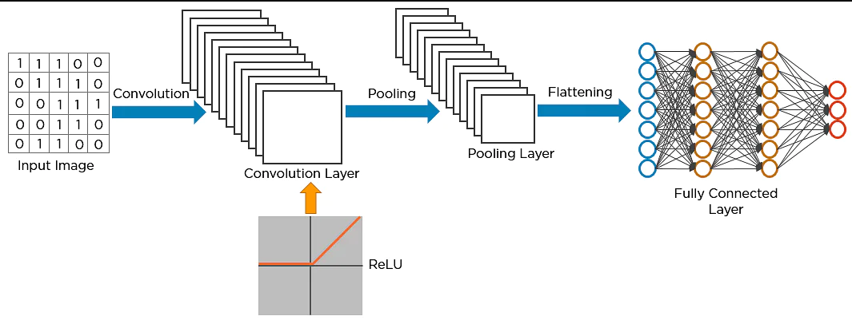

Fig. 1. Layers of Convolution Neural Network

a. Convolution Layer:

Convolution layer is the building block of CNN. This is the very first layer of CNN. We used Conv2d with 32 filters and the dimension of kernel considered is (2,2). This layer is used to extract various features from the input image. In this layer, a mathematical operation namely Convolution of input image with the filters is performed. Here every filter or kernel slides over the complete image searching for the feature to be present. This decreases the size of the image. The dot product of the input image and filters gives featuremap as an output. Similarly, a set of featuremaps are obtained with in the convolution layer and are passed to the further layers.

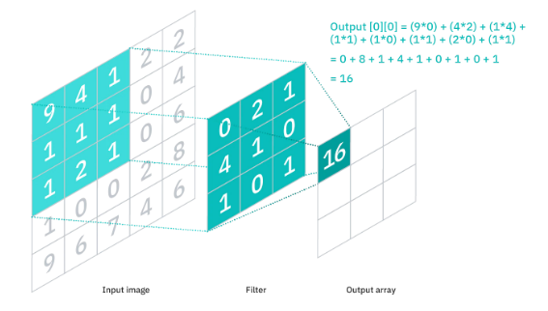
Fig. 2. Convolution between input image and filters

After each and every convolution operation, an activation function – Rectified Linear Activation function is applied on the feature map introducing non-linearity to the model. ReLu function returns 0 for negative values and returns the same positive number for the positive numbers.
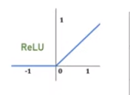
Fig. 3. Graph depicting ReLu Activation function

b. Pooling Layer:

There are different types of pooling layer: Max Pooling, Min Pooling, Average Pooling. We assumed Max Pooling in training our model with a pool size of (2,2). Max Pooling selects the maximum element from the region of feature map. The output from the pooling layer would be also a feature map which consist of the most prominent features of the previous featuremaps.

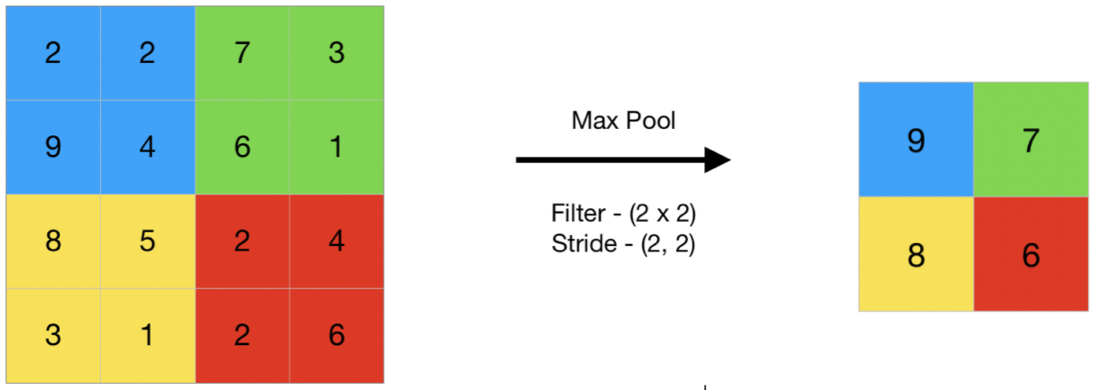
Fig. 4. Max Pooling Operation

c. Fully Connected Layer:

The output of the pooling layer is the input to the next fully connected layer. There may be one or more of these layers. Here every node in the first layer is connected to every node of next layer. Fully Connected Layers perform classification based on features obtained from the previous layers.

The output from the CNN will be indicating the pest that is present in the input image uploaded.

Pest Classification

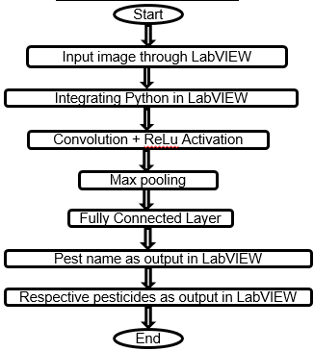
Fig. 5. Flowchart depicting Image Classification

- Get input image from LabVIEW with NI Vision Development Module using IMAQ Create, IMAQ Read pallets.
- Integrate Python in LabVIEW using Open Python Session, Python Node, Close Python Session with Connectivity Module.
- Import TensorFlow in Python and develop a CNN model with Keras.
- Perform Convolution operation using Conv2D Layer with ReLu activation function and pass the feature maps to the next layers and perform MaxPooling with a pool size of (2,2).
- Flatten the output and perform computations in fully connected layer and the model is trained.
- Load the trained model and convert images to NumPy arrays for passing into Machine Learning Model.
- Get the output into LabVIEW using Python Node pallet in connectivity module.
- Show respective pesticides for the detected pest using Case Structure pallet in LabVIEW.

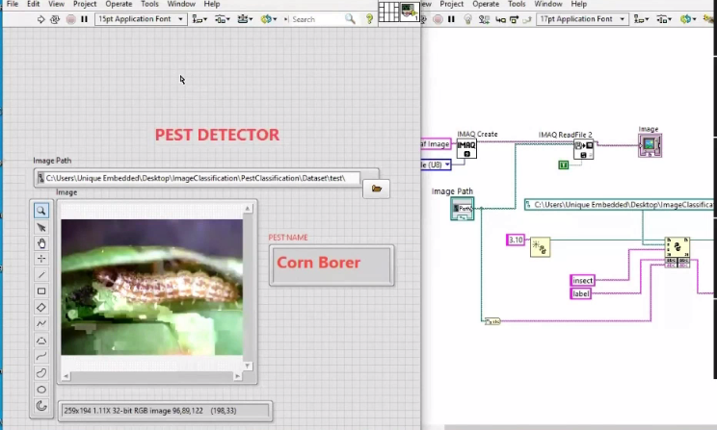
Fig. 6. Pest name as output in LabVIEW

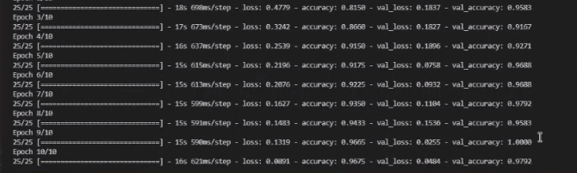
Fig. 7. Trained Model Accuracy

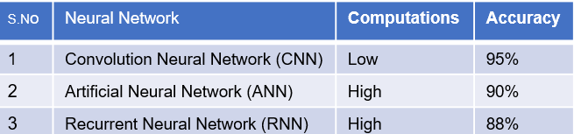
Fig. 8. Comparison of different Neural Networks

Conclusion and Future Work
Our trained CNN model gave the best results in classifying the pests. We have achieved an accuracy of 95%. We have shown the effectiveness of CNN in classifying pests and observed that CNN performance is better than Artificial Neural Network. We have shown the use of LabVIEW with its graphical user elements. Further we would work on Leaf disease detection to help farmers. We would try to develop a model with less complexity and less computations than the available models. We would like to work on different technologies like MATLAB and Yolo, e.t.c.

References

- “Image Classification with Deep Learning and Comparison between Different Convolutional Neural Network Structures using TensorFlow and Keras”
- -Karan Chauhan, Shrwan Ram.Volume 5, Issue 02, February -2018
- [2] “Custom Dataset Creation with TensorFlow Framework and Image Processing for Google Trex”- Dhananjai Bajpai, Lili He. May 28,2021
- [3] “Ensemble of Hybrid CNN-ELM Model for Image Classification” -'Gaurav Jaiswal', 'Suresh Prasad Kannojia’ 7-9 Jan. 2018
- [4] "Testing the quality of cereals and pulses using LabVIEW". Malini, Narmatha.13 – 14 May 2021
- https://blog.keras.io/building-powerful-image-classification-modelsusing-very-little-data.html
- B. Kim and B. Zhang, "Hangul Handwriting Recognition using Recurrent Neural Networks", KIISE Transactions on Computing Practices, vol. 23, no. 5, pp. 316-321, 2017.
- P. Kumar, "Handwriting Recognition using Tensor Flow and Convolutional Neural Networks", International Journal for Research in Applied Science and Engineering Technology, vol. 6, no. 4, pp. 901-903, 2018.

